Article 11 — The Visibility Layer
Michal Doroszewski

You’re flying an aircraft at night. The cockpit looks modern — glass displays, soft backlighting, clean lines. Everything suggests control. You tap the altimeter and it flashes, then disappears. You check the navigation display and it shows a map with no labels. You check engine telemetry and it responds with a polite but useless message: “Unavailable in this environment.” You glance at the horizon indicator and it shows a straight line, then a question mark, then nothing at all.

Outside the cockpit windows, the sky is clear, but the ground is covered in fog so dense it looks like a second ocean. You can hear the engines. You can feel the aircraft responding. But you can’t see the terrain, and half the instruments that should tell you what’s happening are either blank, delayed, or lying. You radio the tower for visibility data. The tower replies that the telemetry you need isn’t permitted in this airspace. You ask again. The tower suggests you try Commercial airspace if you want full diagnostics.

You haven’t changed. The aircraft hasn’t changed. The flight plan hasn’t changed. The only thing that changed was your ability to see the truth.

That is the Visibility Problem. Not the “bad logging” kind — the architectural kind. The kind that appears when cloud systems are deployed inside boundaries that block the very signals needed to operate, secure, and modernize them. The kind that turns a cockpit into a guessing booth.

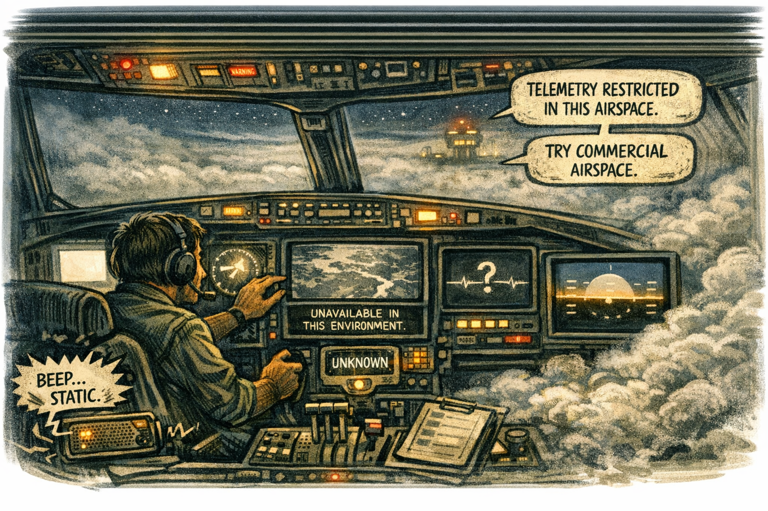
<<Comic Image Inserted Here>>

Visibility is the first layer of modernization
Visibility is the first layer of modernization because nothing else works without it. Every operational decision — security, performance, identity, governance — depends on the ability to observe reality. In Commercial environments, visibility is rich, continuous, and actionable. In GCC‑Moderate, visibility is partial, delayed, and often missing. Modernization cannot begin until visibility is restored.

The FedRAMP Moderate boundary was built for static workloads
The FedRAMP Moderate boundary was built for static workloads, not dynamic cloud platforms. That mismatch creates architectural blindness. Telemetry is filtered or missing. Session data arrives incomplete. Risk signals show up late. Device posture is misclassified. Location and timing drift away from reality. Diagnostic endpoints sit behind walls that were never designed for cloud systems. The system isn’t hiding information. It’s operating inside a fog.

Headquarters and field offices experience this fog differently
Headquarters and field offices experience this fog differently. Headquarters sits close to cloud egress, identity controllers, and diagnostic endpoints. Field offices sit behind WAN optimizers, MPLS circuits, and inspection layers. Headquarters sees clean signals. Field offices see noise. The same workload behaves differently. The same user receives different outcomes. The same policy produces different effects. The architecture creates two realities — one visible, one obscured — and the system enforces both.

When visibility collapses, teams blame tools
When visibility collapses, teams blame tools. Security blames logging. Network blames routing. Identity blames configuration. Operations blames telemetry. Leadership blames vendors. Everyone is correct. Everyone is wrong. The failure is architectural. The boundary blocks the signals. The WAN distorts the timing. The inspection layers delay refresh. The region model misleads location. The system isn’t broken. It’s blindfolded.

Modernization stalls without visibility
Modernization stalls without visibility because modernization depends on feedback, and feedback depends on telemetry. When visibility is missing, diagnoses become speculative, optimizations become ineffective, security becomes reactive, governance becomes inconsistent, and leadership receives reports that contradict each other. This is not dysfunction. It is architectural opacity.

The visibility problem is not caused by bad logging
The visibility problem is not caused by bad logging, poor configuration, or lack of expertise. It is caused by an architecture that blocks the very signals needed to operate cloud systems. The boundary filters telemetry. The WAN distorts timing. The inspection layers delay refresh. The region model misleads location. The diagnostic endpoints are unreachable. You cannot diagnose what you cannot see. You cannot secure what you cannot observe. You cannot optimize what you cannot measure. You cannot modernize inside a fog.

Visibility must be restored
Visibility must be restored. Telemetry must be allowed through the boundary. Timing must be preserved across the WAN. Inspection layers must allow refresh. Region awareness must reflect reality. Diagnostic endpoints must be reachable. Only then can cloud systems behave predictably. Only then can teams diagnose with confidence. Only then can modernization move forward without superstition.

About the Author
Michal Doroszewski is a technology strategist focused on cloud architecture, identity platforms, and federal modernization. He writes about the structural and architectural forces that shape government IT, translating complex technical constraints into clear, accessible narratives for leaders and practitioners.

